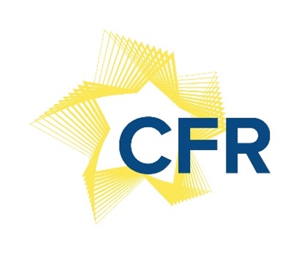

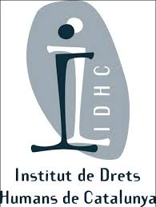

Experience Exchange Workshop (EEW)
Utrecht University│ 29 January 2018

9.25 - 10.00 │ Introduction
Philip Langbroek, project coordinator of the CFR project in The Netherlands
José Manuel Pureza, project coordinator of the CFR project
Bas van Bockel, assistant professor of EU law at Utrecht University

10.00 - 11.30 │ Keynote speakers and discussion
10.00-10.30 │ José Manuel Pureza: Social, political and legal challenges to the implementation of the Charter of Fundamental Rights

10.30-11.00 │ Manon Julicher: The relational scope/scope ratione personae of the Charter in relation to other fundamental rights documents

11.00-11.30│ Discussion and questions

11.45 - 12.45 │ Overview of the Charter Implementation
Each partner country presents the situation relating to the Charter enforcement (overview of the Charter application in each one of the countries)

13.45 - 15.15 │ Case law review by participants
Presentation and discussion of national or CJEU case law on the application of the Charter by each partner country presents

15.30 - 17.00 │ Discussion

